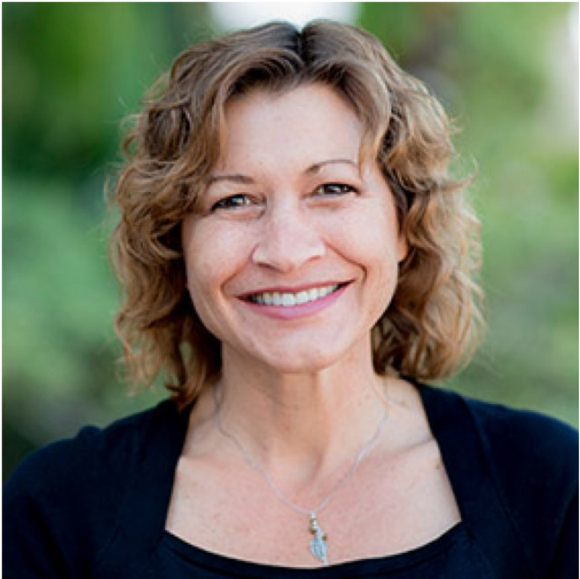

THE INTERSECTION OF FAITH AND SCIENCE AT PLNU
In Latest News, News by Emilyn Giddings April 4, 2019
LOMAbeat.com

In the transition to learning about science in college, some students may have felt deceived by the church or by their parents. In some cases, they believe they could have been deceived into believing in God too, says April Cordero, PLNU biology professor.

“I have two boxes of Kleenex in my office,” says Cordero. “There are some students who have had experiences in their past…They’ve been told that if you learn about evolution, it’s a slippery slope to atheism and you’re letting the devil get a foothold. If you don’t accept a six-day, young earth interpretation of Genesis 1, then you can’t accept anything else that comes after that. They’ve been told that, and they’ve believed that. Then they see some of the data, a lot of the data, and it’s hard to reconcile those two things.”

Cordero says she worries that someone may take her evolution course and struggle with their faith as a result. She includes topics in her courses for students to see that is not necessary.

“When we prevent allowing people to ask questions and pursue deep difficult questions, we risk having them lose their faith,” says Cordero. “We [the biology department] take the approach of asking them the hard questions. Let’s dig in and see what the theologians and biblical scholars say. It’s very complicated, so we do a lot of things in my class to help them think about their faith and see if they can reconcile both.”

Cordero mentions the conflict between science and faith in the church, saying, “You’ve got scientists who don’t want to go to church, who think they have to leave their brain at the door. I’ll check my brain at the door, my rationality at the door in order to be a Christian, which isn’t true, but they feel that way. That’s their perception. So, they’ve rejected faith. We’ve got a lot of young people in the church who are interested in science and Christians don’t always support that. We need to, as a church, engage in this conversation. This is creation and we have ways to study it.”

Cordero says that only our interpretation is in conflict, not God.

“If we see a conflict between our study of creation and The Word, then that means we need to press in harder and farther and figure out what we are interpreting incorrectly. That doesn’t mean that science has to give way to the Bible, and it doesn’t mean the Bible has to give way to science. It’s trying to find truth in both, doing the best job we can of both. The role of faith and science is to find truth in both things related to faith and in sciences.”

Cordero thinks it is important for the church to address science to feel confident in using our minds to pursue an understanding of our universe. Pastors should be open to allowing scientific findings to be seen as acceptable among the Christian community, according to Cordero.

Derrel Falk, professor emeritus of biology, speaks about the relationship between faith and science.

“Science is pretty clear that evolution has occurred,” says Falk. “All life arose through the evolutionary process.”

Falk’s book, The Fool and the Heretic, includes a model of Christians holding opposing views of origins and touches on the way to have these conversations.

“The book is written in the perspective voices,” says Falk. “It places the two views side by side in the book, but it focusses on how to have conversations.”

Falk mentions the importance of these conversations within the Christian faith to live a meaningful life through following Jesus.

“We as Christians need to function in this world and speak into this world,” says Falk. “It is difficult to speak into this world with credibility if we disagree with all science says. How do you remain relevant when you don’t acknowledge science?”

Falk says, from the theological side, that everything happens because of God’s presence. Without the presence of God, the world would just fall into chaos.

“His ongoing presence, the spirit of God, continues upholding the universe,” says Falk. “Without his ongoing presence, everything would cease to exist.”

Cordero is a team leader for a PLNU event, Live United.

“Live United is interested in sharing stories across campus of ways faculty have united and integrated their faith, findings from the sciences and their practice,” says Cordero. “Science is a part of our whole world right now. How do we integrate these things together so that we don’t have a little silo of, here’s my faith: it has nothing to do with my job, which has nothing to do with sciences and the world? No, it’s all one. These faculty share their stories with how they united and bring in the complicated questions and tackled those and what they understand and don’t understand.”

A showcase on April 9 from 3–5 p.m. in the Brown Chapel Foyer will present student outputs on topics of faith and science.

